Slide 1 |  | Hello, my name is Richard Hren, and this presentation provides an overview of the proposed DriverPass system. I will explain the major system requirements, how customers and employees will interact with the system, how important processes such as practice testing and lesson scheduling will work, and how the design addresses security and system limitations. The goal of this design is to provide DriverPass with a reliable and easy-to-use system that supports both online driver education and behind-the-wheel training.
Slide 2 |  | This slide summarizes the main requirements for the DriverPass system. Functional requirements describe what the system needs to allow people to do. Customers need to be able to create and manage an account, purchase a training package, complete online courses and practice tests, and schedule or manage driving lessons. These functions directly support DriverPass's goal of giving students both online preparation and behind-the-wheel training in one system.  The nonfunctional requirements describe how the system should operate. DriverPass needs the system to be secure and dependable because it will contain customer, scheduling, test, and payment-related information. A web-based design allows customers and employees to use the system through a normal browser and from common devices such as computers, tablets, and smartphones. The system should also be able to grow as DriverPass adds more customers while still allowing updates and maintenance with as little disruption as possible.
Slide 3 |  | This diagram gives an overall picture of who will use DriverPass and what each person needs to accomplish in the system. Customers can register and log in, reset a password, purchase a package, schedule or change a lesson, take online courses and practice tests, and review their progress. A secretary can help register customers and manage lesson scheduling when assistance is needed.  DriverPass employees have responsibilities that match their jobs. Drivers can view their schedules and enter notes from driving lessons. The owner can review reports and manage the training packages offered to customers. The IT officer can manage user accounts and control employee access. The system also receives updated content associated with DMV information.  Organizing the system this way helps DriverPass give each person access to the functions they need without making the system unnecessarily complicated. It also supports the client's need for one centralized system that connects customer training, scheduling, employee responsibilities, and business management.
Slide 4 |  | This diagram shows the process a customer follows when taking a DriverPass practice test. The customer begins by logging into their account, selecting a practice test, and starting the test. The system displays each question, the customer provides an answer, and the system records that answer before moving to the next question.  This process continues until there are no more questions. Once the test is complete, the system calculates and records the customer’s score, updates their test progress, and displays the results for the customer to review.  This design meets DriverPass’s needs by giving students an organized way to practice for their driving exams and immediately see how they performed. Saving the results also allows customers to track their progress over time and identify areas where they may need additional preparation.
Slide 5 |  | This diagram focuses on the process of scheduling a driving lesson. The customer, or a secretary assisting the customer, begins by accessing the customer's account and selecting the scheduling option. The customer chooses a preferred date and time, and DriverPass checks whether both a driver and a vehicle are available.  If the requested time is available, the system assigns the driver and vehicle, allows the lesson to be confirmed, saves the reservation, and sends a confirmation. If the requested time is not available, the customer is shown a scheduling conflict and can select another date or time.  This process meets DriverPass's needs by checking the resources required for a lesson before the appointment is finalized. It helps prevent scheduling conflicts, makes the process easier for customers and staff, and provides confirmation so the customer knows the reservation was successfully saved.
Slide 6 |  | Security was considered throughout the DriverPass design because the system will store customer information, account information, schedules, test results, and other business data. Customers and employees will sign in before accessing protected information, and employees will only be given access to the areas needed for their responsibilities.  Information sent between the user and DriverPass will use a secure connection, and passwords and other sensitive information will be protected when stored. Package purchases will use secure payment processing rather than exposing payment information unnecessarily. Regular backups will also help DriverPass recover important customer and business information if data is lost.  Together, these protections help DriverPass provide customers with a system they can trust while also protecting the company's day-to-day operations.
Slide 7 | 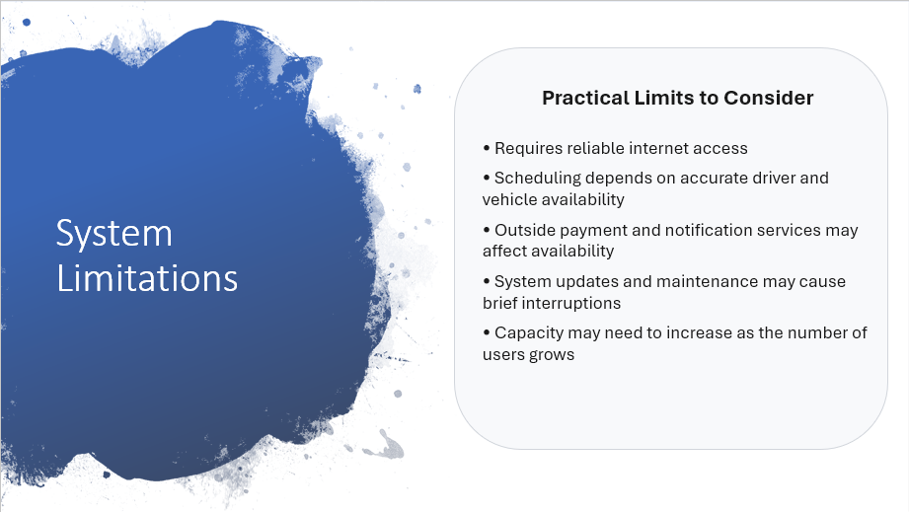 | The proposed system meets DriverPass's major needs, but there are practical limitations to consider. Because the system is web based, customers and employees will need a reliable internet connection to use it. Scheduling also depends on the driver and vehicle availability information being kept accurate. If that information is not current, the system cannot make the best scheduling decision.  DriverPass will also rely on outside services for functions such as secure payments and customer notifications. An interruption with one of those services could temporarily affect that part of the customer experience. The system will require regular updates and maintenance, and as DriverPass grows, additional capacity may be needed to continue providing dependable service.  These limitations can be managed through good operating procedures, maintenance, monitoring, and planning for future growth.

